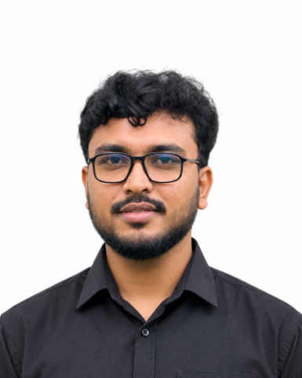

KHAN ISRAK AHMED
Address: Dreams Tower (Floor:8/C) 264/2/I,
West Manikdee Dhaka Cantt.Dhaka-1206
Mobile: 01516183490.

E-mail: israk.ahmed275@gmail.com
GitHub: github.com/KhanIsrakAhmed
Portfolio: israk-portfolio.vercel.app

1. Contact Detail:
Mailing /Present Address | Dreams Tower (Floor:8/C) 264/2/I,  West Manikdee Dhaka Cantt.Dhaka-1206
Permanent Address | Dreams Tower (Floor:8/C) 264/2/I,  West Manikdee Dhaka Cantt.Dhaka-1206
Contact | Mobile: +88-01516183490
E-mail | israk.ahmed275@gmail.com
2. Career Objective:
Long Term | To secure a position as a Lecturer in the Department of Computer Science and Engineering, where I have the ability to use my educational background and expertise in Data Science, Artificial Intelligence, and Deep Learning to effectively teach, conduct impactful research and contribute to students’ academic and professional growth. My aim is to contribute to the university through continuous learning, innovative teaching methods and research in emerging areas of CSE.
Personal Goal | To develop amicability, honesty, simplicity and integrity in character
3. Academic Detail:
B.Sc.  Computer Science and Engineering (CSE)  2026 | CGPA 3.46 (Out of 4)  Session 2022-2026  Department of Computer Science and Engineering  United International University (UIU)
HSC  Science  2020 | GPA 5.00  Session 2018-2020  Shaheed Ramiz Uddin Cantonment College (SRCC)  Dhaka Board
SSC  Science  2018 | GPA 4.78  Session 2017-2018  Adamjee Cantonment Public School (ACPS)  Dhaka Board
4. Professional Experience:
Grader  United International University  (2023–2024) | - Object-Oriented Programming.  - Structured Programming Language.

5. Skill:
Programming Languages | C, C++, Java, Python
Web Development | HTML, CSS, Bootstrap, JavaScript, Node.js, React.js
Database Management | MySQL
Backend Development | PHP, Node.js

6. Other Detail:
Language Proficiency | Fluent in English & Bengali (speaking, reading, writing, &  understanding).
Interest | Robotics, Reading, Perfume collection, Traveling, Photography, Research & Development.

7. Projects and research:
FYDP | Developing a Legally-Grounded Evaluation Framework for Retrieval-Augmented Generation Systems in the Context of Bangladeshi Law
Software Projects | - CholoKini - a dynamic online auction platform designed to connect buyers and sellers through a competitive and interactive bidding environment.  - Language Learning App - An interactive and beginner-friendly Language Learning App designed to help users improve their vocabulary, pronunciation, and language skills through engaging lessons and quizzes.
Research Projects | - Automated Visual Inspection for Defect Detection in Electronic Components  - Deep Learning-Based Multiclass Disease Detection System for Jute Plants

8. Personal Detail:
Father’s Name |  | Md. Ali Aslam Khan
Mother’s Name |  | Parvin Aslam
Date of Birth |  | September 01, 2003
Place of Birth |  | Dhaka, Bangladesh
Nationality |  | Bangladeshi (by birth)
Religion |  | Islam
Marital Status |  | Unmarried
Sex |  | Male
9. Reference:
Engr. Khan Mowdud Ahmed  Manager (Project Coordination) | Tropical Homes Limited  Email:  mowdudahmed121@gmail.com  Cell no: +8801718-487382
Md. Forhad Hossain Arif  Head of Operation | Charity Right Bangladesh  Email:  forhad@charityright.com.bd  Cell no: +8801756354800

I, hereby, consciously ascertain that to the best of my knowledge and belief, all particulars given are true and correct; and understand that should any false statement(s) and or omission(s) be made herewith, I personally will be liable.

Signature:

Date: Tuesday, September 21, 2026

